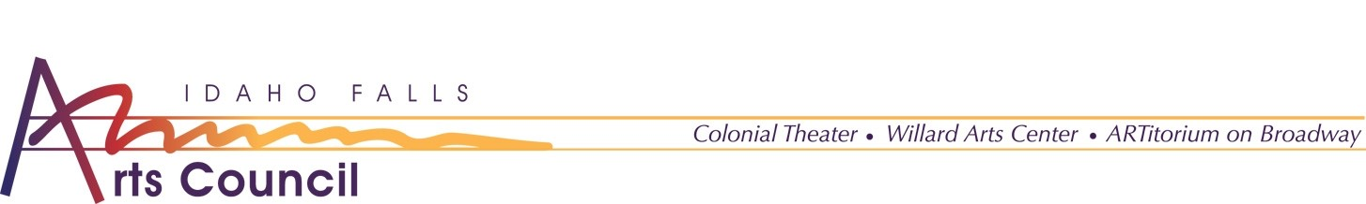
PRESS RELEASE
Idaho Falls Arts Council presents the
Idaho Central Credit Union Carr Gallery Sessions

The Idaho Falls Arts Council is pleased to announce the first performance of the Idaho Central Credit Union Carr Gallery Sessions, Luca Stricagnoli. The Carr Gallery Sessions take place in the Carr Gallery at the Willard Arts Center.

“These performances are unique because they are often new and unique artists,” said Executive Director Brandi Newton. “The audience has the opportunity to be up close and personal and experience the music in a club-like environment.”

Idaho Central Credit Union Carr Gallery Sessions Schedule:

October 27th, 2021 – Luca Stricagnoli
November 6th, 2021 – Rob Ickes & Trey Hensley
February 24th, 2022 – Jason Lyle Black
April 28th, 2022 – Matt Nakoa

Out of an abundance of respect for our community's health care workers, masks are required when social distance cannot be maintained. Masks are required to enter the building and when in the Carr Gallery. Masks may be removed when consuming refreshments.

The Idaho Falls Arts Council is a private nonprofit organization which owns and operates: ARTitorium on Broadway, The Colonial Theater, and the Willard Arts Center. The mission of IFAC, in cooperation with other arts organizations, is to educate our community and enrich its quality of life by promoting, advocating, and presenting a broad spectrum of visual and performing arts in eastern Idaho.
For questions regarding information contained in this release, please contact Jordyn Eckman, Marketing Assistant, or at jeckman@idahofallsarts.org or at 208-522-0471

